CYBER SECURITY
A Beginner's Guide to Staying Safe Online

SUBMITTED BY

Name: Aman Pandey
Course: BCA – MCA Integrated
Semester: I
Academic Year: 2026–27

--------------------------

TABLE OF CONTENT
-------------------------

1. Introduction to Cyber Security
2. What is Cyber Security?
3. Types of Cyber Threats
4. Malware and Computer Viruses
5. Phishing Attacks
6. Password Security
7. Two-Factor Authentication
8. Safe Internet Browsing
9. Cyber Security in Daily Life
10. Conclusion
11. References
---------------------------------------------

1. INTRODUCTION TO CYBER SECURITY
---------------------------------------------

Technology has become an important part of our daily lives. People use computers, smartphones and the internet for education, communication, shopping, banking and entertainment.

However, the increasing use of the internet has also created security risks. Personal information, passwords and important files may be exposed to online threats.

Cyber security helps protect digital devices, networks and information from unauthorized access and cyber attacks. It plays an important role in keeping our digital activities safe.

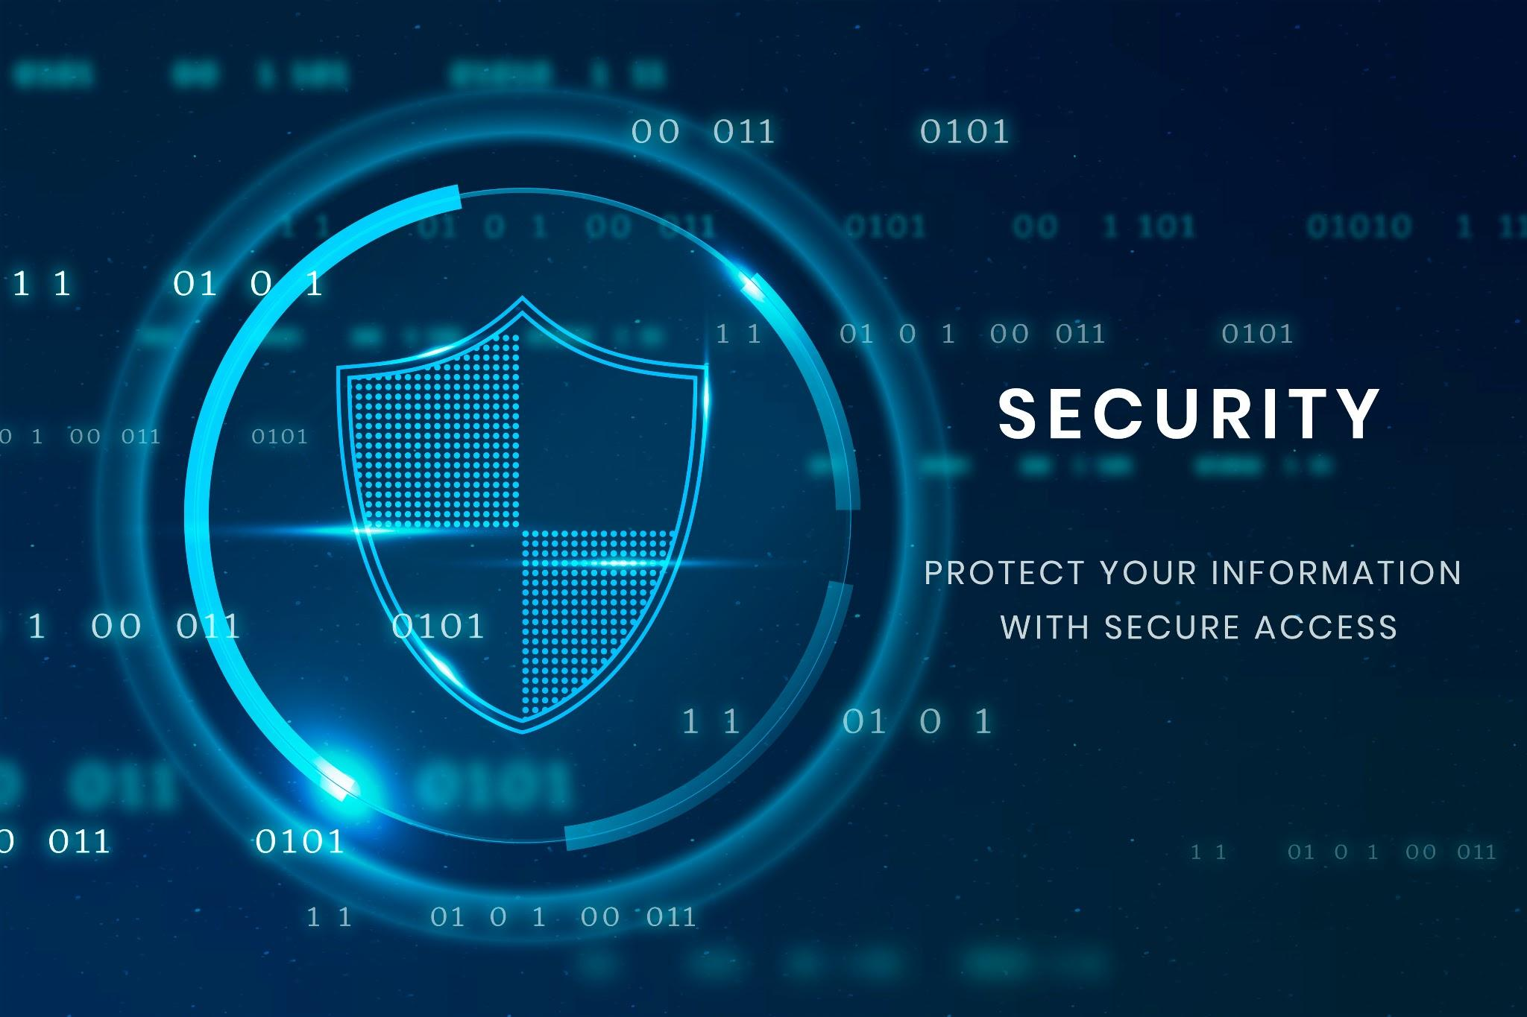 Figure 1: Basic Concept of Cyber Security.

--------------------------------

2. WHAT IS CYBER SECURITY?
--------------------------------

Cyber security refers to the practice of protecting computers, mobile devices, networks, applications and data from digital attacks, unauthorized access and damage.

The main purpose of cyber security is to maintain the confidentiality, integrity and availability of information.

Importance of Cyber Security:

• Protects personal information.
• Prevents unauthorized access.
• Helps secure online banking.
• Protects important files and documents.
• Creates awareness about online threats.
• Supports safe communication over the internet.

--------------------------------

3. TYPES OF CYBER THREATS
--------------------------------

A cyber threat is a possible danger that can affect computers, networks or digital information.

Some common cyber threats are:

1. Malware:
Malware is harmful software designed to damage devices, disrupt systems or access information without permission.

2. Phishing:
Phishing is a technique in which attackers use fake emails, messages or websites to trick people into sharing sensitive information.

3. Ransomware:
Ransomware is a type of malware that locks or encrypts files and demands payment to restore access.

4. Spyware:
Spyware is software that secretly collects information about a user's activities.

5. Password Attacks:
These involve attempts to gain unauthorized access to accounts by compromising password.

Threat | Description
Malware | Harmful Software
Phishing | Fake message or websites
Virus | Harmful program
Ransomware | Locks or encrypts data

-----------------------------------------------

4. MALWARE AND COMPUTER VIRUSES
-----------------------------------------------

Malware stands for malicious software. It is designed to harm computers, steal information or perform unwanted activities.

A computer virus is a type of malware that can attach itself to files or programs and spread when they are used.

Common types of malware include:
• Virus
• Worm
• Trojan Horse
• Spyware
• Ransomware

Ways to stay protected:

• Use trusted security software.
• Avoid unknown email attachments.
• Download applications from trusted sources.
• Keep your operating system updated.
• Scan files when necessary.


Figure 2: Malware and computer virus.
--------------------------------

5. PHISHING ATTACKS
--------------------------------

Phishing is a common online threat in which fake messages or websites are used to deceive users.

These messages may appear to come from banks, companies or familiar services. Their purpose is often to collect passwords, account details or personal information.

Warning signs of phishing:

• Unknown or suspicious sender.
• Unexpected requests for personal information.
• Unusual links or attachments.
• Spelling and grammar mistakes.
• Messages creating unnecessary urgency.

Safety tips:

• Verify the sender before responding.
• Do not share passwords or OTPs.
• Check website addresses carefully.
• Report suspicious messages.
--------------------------------

6. PASSWORD SECURITY
--------------------------------

Passwords help protect personal accounts and digital information. A strong password makes unauthorized access more difficult.

Characteristics of a strong password:

• It should be sufficiently long.
• It should be difficult to guess.
• Avoid using personal information.
• Use different passwords for important accounts.
• Never share passwords with others.

Password security is an important part of online safety.

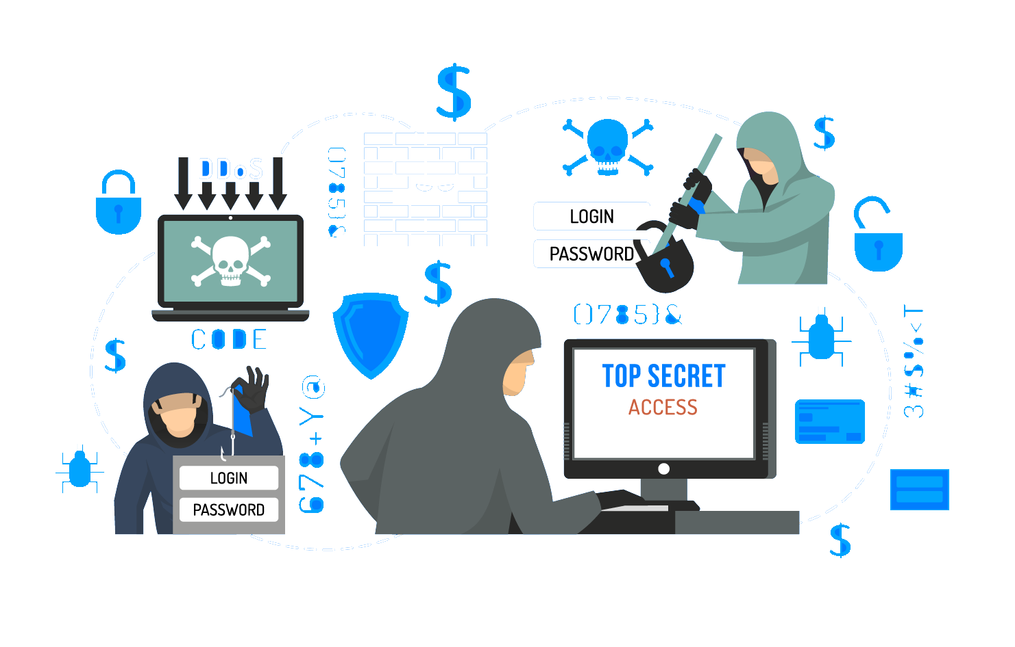
Figure 3: Password security.
--------------------------------

7. TWO-FACTOR AUTHENTICATION
--------------------------------

Two-Factor Authentication (2FA) is an additional security method that requires two different forms of verification to access an account.

For example, a user may enter a password and then verify their identity using an authentication app or another approved method.

Benefits of 2FA:

• Adds an extra layer of security.
• Helps protect accounts.
• Reduces the risk of unauthorized access.
• Improves account safety.

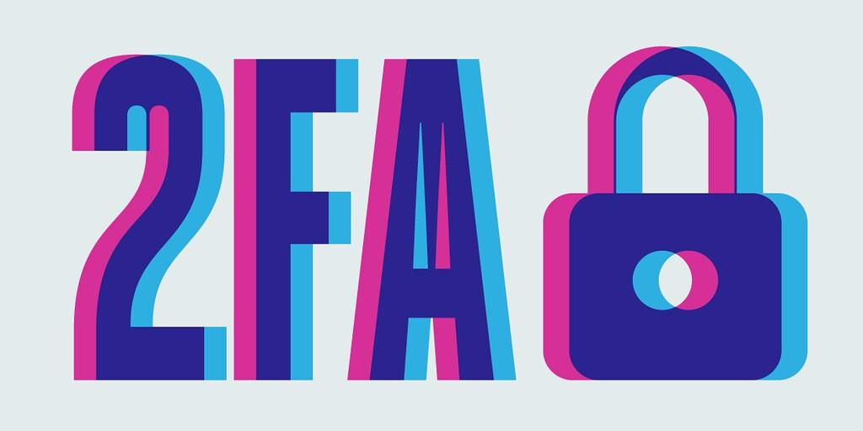
Figure 4: Two factor Authentication

--------------------------------

8. SAFE INTERNET BROWSING
--------------------------------

Safe internet browsing means using websites and online services carefully to protect personal information and devices.

Important safety practices:

1. Visit trusted websites.
2. Avoid clicking suspicious links.
3. Keep browsers updated.
4. Use secure internet connections.
5. Avoid sharing personal details unnecessarily.
6. Log out from accounts on shared computers.
7. Review website permissions before accepting them.
--------------------------------

9. CYBER SECURITY IN DAILY LIFE
--------------------------------

Cyber security is useful in many areas of everyday life.

Education:
It helps protect student accounts, online classes and academic documents.

Banking:
It helps protect financial information and online transactions.

Communication:
It supports the safe use of email and messaging platforms.

Shopping:
It helps users identify trustworthy websites and protect payment information.

Social Media:
It helps protect accounts and personal information from unauthorized access.
--------------------------------

10. CONCLUSION
--------------------------------

Cyber security has become essential in the modern digital world. As people increasingly depend on computers, smartphones and the internet, protecting personal information and digital devices is very important.

By using strong passwords, enabling two-factor authentication, avoiding suspicious links and keeping software updated, users can improve their online safety.

Cyber security is not only the responsibility of technology experts. Every internet user should understand basic security practices and use technology responsibly.
----------------------

11. REFERENCES
-----------------------

1. National Cyber Crime Reporting Portal – https://cybercrime.gov.in/
2. CERT-In – https://www.cert-in.org.in/
3. National Institute of Standards and Technology – https://www.nist.gov/cybersecurity
4. Cybersecurity and Infrastructure Security Agency – https://www.cisa.gov/
5. Google Safety Center – https://safety.google/

END OF DOCUMENT

